Results

The t-test results show both similarities and variations in the experiences of local and international students at IBS, providing insight into academic perceptions, support systems, and financial issues.

The study found no significant change in judgements of the overall academic experience (T-Statistic: 0.22, p = 0.83) or the availability of mental health supports (T-Statistic: 0, p = 1). Both groups tend to have similar perspectives on these issues, implying that the academic and mental health support provided by IBS is viewed as equitable and consistent across populations. This parity emphasises the university's ability to provide an inclusive and cohesive academic atmosphere that caters equally to local and international students.

In terms of the cost of studying at IBS, the analysis (T-Statistic: 1.34, p = 0.19) demonstrates no significant difference between local and international students. While affordability remains an important factor for both groups, the absence of statistical significance shows that they share a view on the financial feasibility of their education, which could be impacted by comparable tuition structures or access to financial aid programs. However, there are variances in students' satisfaction with university services like counselling, academic advising, and career guidance. The t-test results (T-Statistic: -2.21, p = 0.034) show that international students valued these services significantly higher than local students. This disparity could indicate differences in expectations or the relative relevance of these services to each group. For international students, such support services may be critical for adapting to a new cultural and educational environment, whereas local students might rely less on them or hold different expectations.

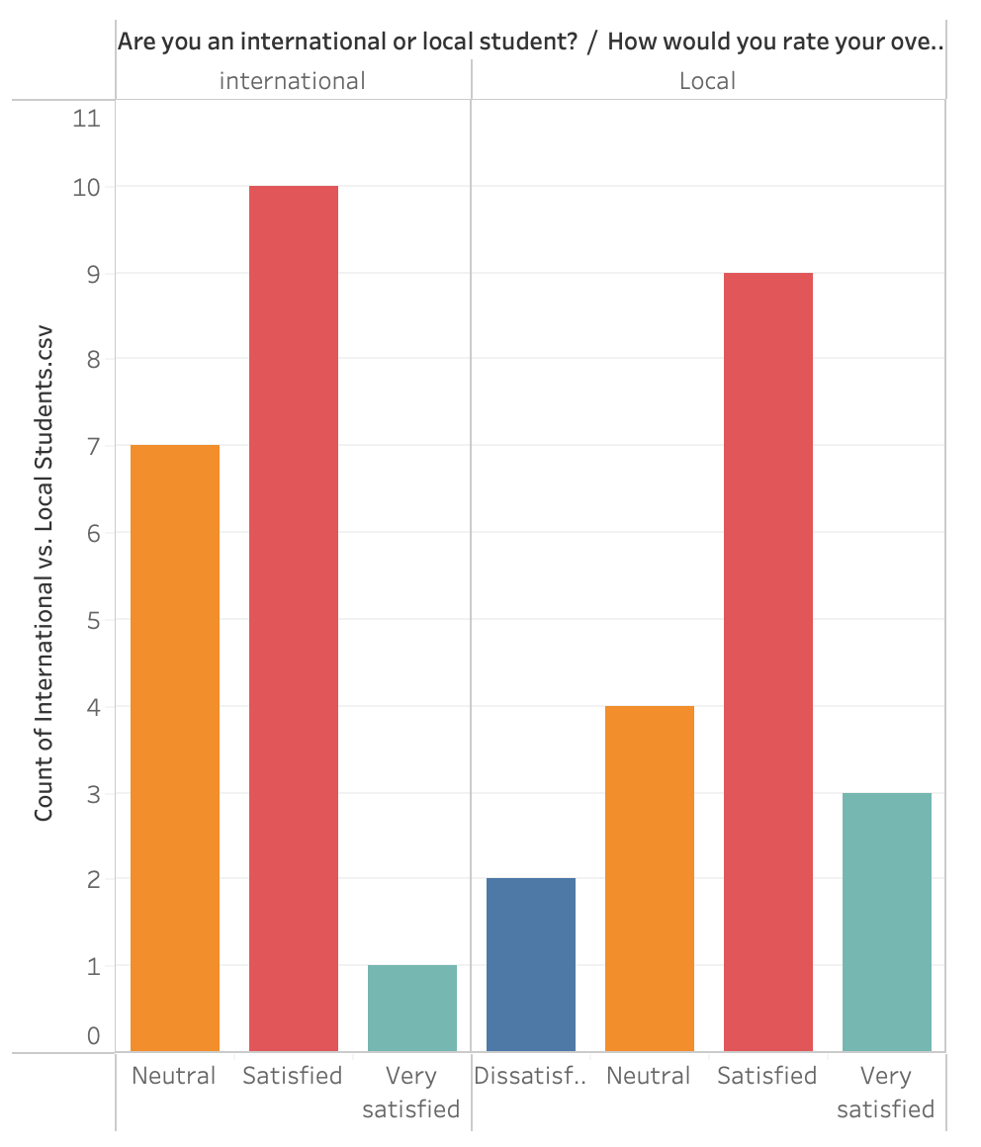

The graph shows the overall satisfaction level of the services provided by the university to both the students local and internation.

Financial challenges proved to be another area of divergence. Local students reported facing significantly greater financial challenges than their international peers (T-Statistic: 2.96, p = 0.0056). This finding might be attributed to systemic differences, such as the availability of scholarships or work opportunities. International students often come prepared with financial plans or receive support from home countries, whereas local students might bear a heavier reliance on part-time work or loans, creating a perception of greater financial strain.

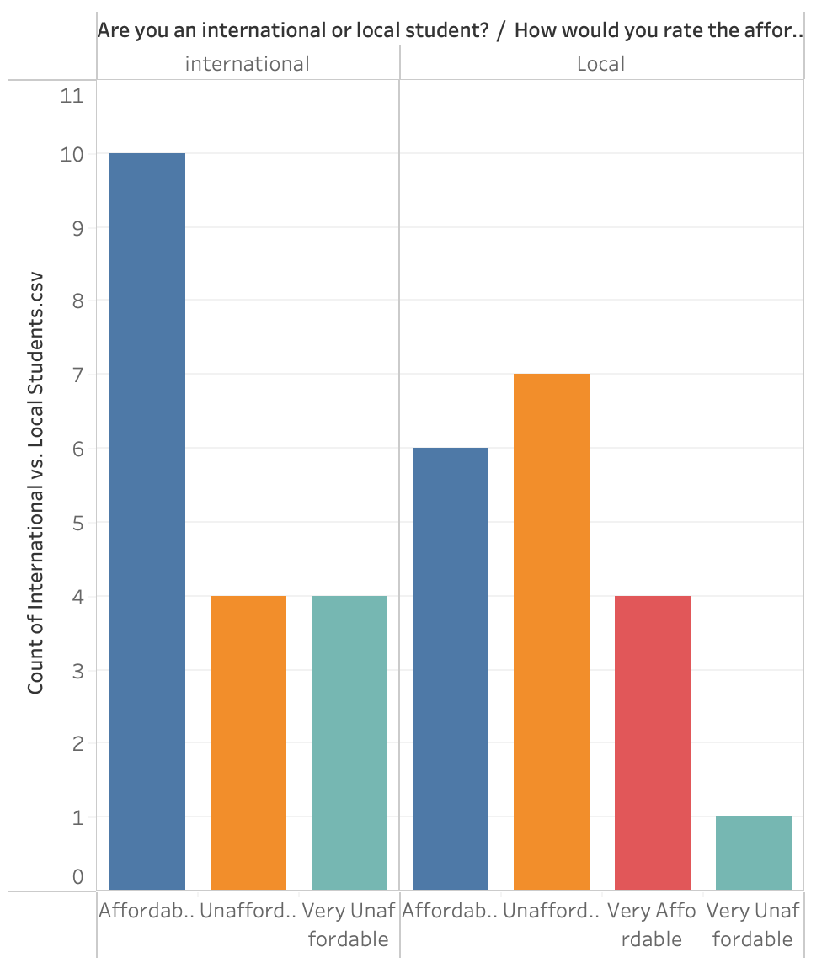

This graph shows the affordability of the fees at the university of both group of students.

Overall, the survey results show that, while local and foreign students have similar experiences in major academic and institutional areas, discrepancies in service satisfaction and financial issues indicate that each group has unique needs and expectations. International students benefit considerably from IBS's strong support services, which appear to help them integrate and succeed. Local students, on the other hand, may benefit from focused measures to address their financial worries and adjust the supply of support services to better meet their expectations.

These findings highlight the need of sophisticated institutional initiatives for improving the student experience. It is critical to maintain a commitment to equal academic excellence and mental health resources. Addressing the financial challenges that local students encounter while personalising support services to their specific requirements will help to close satisfaction gaps. Such a strategy would ensure that IBS remains a centre of inclusivity, equity, and opportunity for both domestic and international students.